**Bremerton Yacht Club**

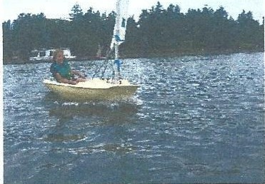**2025 Junior Sailing Cam.ps Fun with Wind and Waves Scholarship Application**

# Financial assistance will be awarded to applicants based upon financial need and the available resources of the scholarship fund. Four consecutive Monday through Friday Camps for ages 8-16, from July 28 through August 22

Scholarships will be selected by an impartial panel of three judges and parents/guardian will be notified within two weeks of submission of application.

Parent or Guardian Name: _______________Phone___________ Email:

Address: City: State Zip

Household Size:

Family members included in household size will include 1) legally married spouse, or 2) a qualified dependent. A person qualifies as a dependent if all of the following apply:

* Dependent is related to primary member (includes: related through marriage, member of household, legally adopted or long term foster child)
* Dependent is financially supported by primary member (furnishes more than half the dependents support during the calendar year). Support includes child support payments paid by a divorced or separated spouse.

Please list all family members/persons financially dependent on you---lNCLUDE YOURSELF

Name Birthdate Scholarship requested Y**/N**

Name Birthdate Scholarship requested **Y/N**

Are you currently employed? Yes No

Is your spouse (if applicable) currently employed? Yes No

Are dependents in your household currently employed? Yes No

**Income verification** Please attach with application.

* A qualifying income scale, based on USDA income eligibility guidelines, is used to determine scholarship award.
* **List family member, type of income and gross monthly amount (before taxes) . Include food stamps, retirement, unemployment, SSI, DSHS, TANF,SSA,ADATSA, VA, etc)**

Individual name Type of income Annual income

Estimated annual household income $___________

**Extenuating circumstances:**

Please explain any extenuating circumstances the scholarship committee should consider when reviewing your application.

Please indicate which weeks student is available:

* Week #1: July 28-Aug 1
* Week#2: August 4-8
* Week#3 August 11- 15

Q Wee #4 August 18-22

I confirm that my child has received passing grades in all classes in his/her current school situation. I also confirm that he/she is in need of financial assistance in order to participate. In addition, I agree that my child is a good candidate for a scholarship to BYC Sailing Camp and will support his/her involvement.

Parent Name: _

Parent Signature: _ Date: _